2018 School Spotlight

Following the merger of Greeley-Wolbach and North Loop-Scotia Public Schools, the Assistive Technology Partnership (ATP) assisted in making their special education services accessible for two students using wheeled mobility devices.

ADA accessible doors were installed between two therapy rooms located on either side of a special ed drop in resource room. The result is a better use of space for students and staff.

A special education therapy area provides privacy for a student to utilize the equipment (photo below)

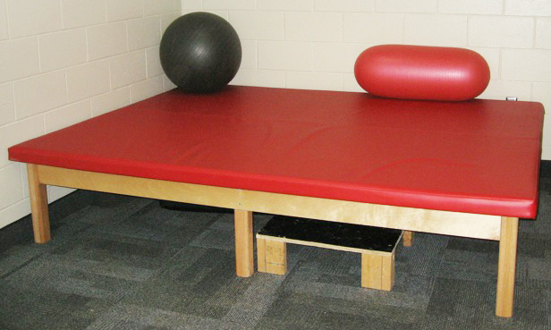

A Rifton Self-Support Station in an accessible restroom pivots to aid transfers to a fixed toilet or commode. The equipment assists the student to stand up and transfer from their wheelchair. It folds flat when not in use. (photo below)





