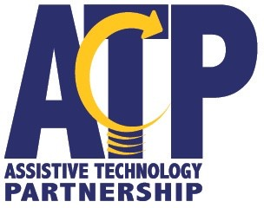
500 S 84th Street PO Box 94987
Lincoln NE 68509-4987 Federal Tax ID: 47-0491233

BILL TO: Invoice Number

Invoice Date

Service provided by: Assistive Technology Partnership

Description: include material & labor | Quantity | Rate | Amount
Total Amount Due
Additional Remarks:

Make checks payable to Nebraska Department of Education Mail to address above

Updated November 2023

