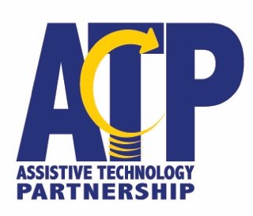

Fee for Service Activities

• Assistive Technology Evaluations (Performed at an ATP office or in the community)

$100.00 per hour

• Training on Specific Devices/Software $100.00 per hour

• Consultation Services $100.00 per hour

• Job Site Evaluations (includes ergonomic evaluations) $100.00 per hour

• Workshops/Seminars Negotiated

• Group Training/Train the Trainer Negotiated

Please note: Fees were set in 2009. A report is generated for any individual fee for service activity. Private individuals should be referred to ATP Funding Coordination. Some fees may be waived or reduced upon review and approval of the request.

How to Make a Referral
• Contact the nearest ATP office to start the process.
• ADA school facility requests: Lilly Blase, (531) 207-2426, Lincoln ATP office

LINCOLN
PO Box 94987, 68509-4987
(402) 471-0734
Toll Free (877) 713-4002
Fax (402) 471-6052
SCOTTSBLUFF
505 A Broadway, Suite 500, 69361
Toll Free (877) 713-4002
Fax (308) 632-1392

OMAHA
1313 Farnam Street, 68102
Toll Free (877) 713-4002
Fax (402) 595-1919
NORFOLK
1212 W. Benjamin Ave., 68701
Toll Free (877) 713-4002
Fax (402) 370-3488

KEARNEY
315 W. 60th Street, Suite 300, 68845
Toll Free (877) 713-4002
Fax (308) 865-5322

10.2023

