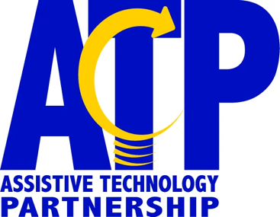
Advisory Council Meeting
Friday, September 20, 2024
10:00 a.m. -3:00 p.m.
In-Person at 500 S 84th Street Lincoln, Nebraska

10:00 a.m. Welcome Joni Thomas

10:15 a.m. Call to Order Joni Thomas

10:30 a.m. Review Meeting Minutes Joni Thomas

10:45 a.m. Rescue and Reuse Event Bryan BIngham
11:00 a.m. Help Hope Live Karli Njaa
Medical Fundraising

12:00 p.m. Council Awards and Elections
Working Lunch Joni Thomas

12:45 p.m. Break

1:00 p.m. All Staff Meeting Review Angie Ransom

1:15 p.m. Program Updates
Marketing Nancy Noha
ATP/Nebraska VR Brooke Harrie
ATP Education Brian Wojick

1:45 p.m. Break

2:00 p.m. Program Updates Cont.
DHHS Programs May Faith
ADA Facilities Lilly Blasé
Resource Coordination Angie Ransom
Directors Report Tobias Orr

2:30 p.m. Questions/Wrap Up Joni Thomas

3:00 p.m. Adjourn Joni Thomas

Page 2

